## 1. Some history of women in maths

In Germany as well as elsewhere, mathematics was not always a male domain. This is, at any rate, what numbers of students at the beginning of the 20th century seem to indicate.

It was not before 1900 that women in Germany were allowed to persue university studies. In the first third of the 20th century, mathematics was disproportionately favored by women. In 1934, while 16% of all university students were female, 22% of mathematics students were female. Between 1925 and 1934, the proportion of women among all beginner students was consistently lower that the women‘s share among math-beginners. After 1934, women were systematically pushed out of the universities. The national socialists passed a law that prescribed (among other things) that the women‘s proportion in university students be 10%.

At that time, in the first third of the 20th century, female math students were headed towards a career in teaching at secondary schools for girls (while the degree of Diplom [the equivalent to a MSc, translator‘s note] was introduced as late as 1942). Since secondary schools for girls had been established around 1900 – just like female enrolment at universities – this was a new vocational field for women. It remains unclear why exactly mathematics shot to the top of the list of popular subjects.

Blunck, Andrea (2007) : “Das Geschlecht der Mathematik“, in: Cederbaum, Carla; von Homeyer, Philipp (eds.): *Ein Moment für Mensch und Mathematik*, Freiburger Verlag, Freiburg. p. 118.

## 2. The vicious circle



Cameron EZ, Gray ME, White AM (2013). “Is publication rate an equal opportunity metric?”, *Trends in Ecology & Evolution* **28:** 7-8.

## 3. Female professors in mathematics

**Percentage of women full professor in Mathematics in 2005 [EWM-European   
 Community]**



*Celletti, Allessandra.* “Percentage of women full professor in Mathematics in 2005 [EWM-European Community]”. In: *Women in Mathematics: when simple numbers become graphs.*

**Map of female mathematics professors in Germany**

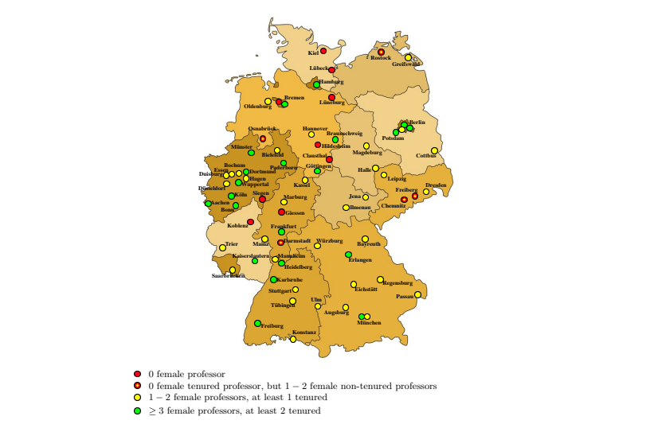

Infusino, Maria. “Map of female professors in Mathematics in Germany”. In: *Women in Mathematics in Germany.* [http://www.math.uni-konstanz.de/~infusino/KWIM/MInfusino-WIMGermany-report.pdf](http://www.math.uni-konstanz.de/~infusino/KWIM/MInfusino-WIMGermany-%09report.pdf). Last accessed: Jan 12, 2021.

## 4. Grants for female scientists

**Participation and success in the ERC calls 2007-14 by gender**

Share of female applicants and grantees by gender: all panels

|  |  |  |  |  |
| --- | --- | --- | --- | --- |
| All panels | Share of women | | Success rate | |
| ERC call | evaluated | funded | F | M |
| **Starting grants (StG)** | **31%** | **26%** | **7%** | **9%** |
| **Consolidator gr. (CoG)** | **29%** | **26%** | **8%** | **9%** |
| **Advanced grants (AvG)** | **15%** | **13%** | **10%** | **12%** |
| **TOTAL** | **25%** | **21%** | **8%** | **10%** |

Share of female applicants and grantees by gender: mathematics

|  |  |  |  |  |
| --- | --- | --- | --- | --- |
| Mathematics | Share of women | | Success rate | |
| ERC call | evaluated | funded | F | M |
| **StG** | **17%** | **14%** | **9%** | **12%** |
| **CoG** | **16%** | **8%** | **6%** | **13%** |
| **AdG** | **6%** | **4%** | **9%** | **16%** |
| **TOTAL** | **13%** | **9%** | **9%** | **13%** |

Average age by gender all panels and mathematics (2007-2014):

|  |  |  |  |  |
| --- | --- | --- | --- | --- |
| StG/CoG 2007-2014 | **All panels** | | **Mathematics** | |
| AdG 2008-2014 | **F** | **M** | **F** | **M** |
| AvG age StG/CoG app | 38 | 37 | 35 | 35 |
| AvG age AdG app | 52 | 53 | 49 | 53 |
| AvG age all app | 40 | 42 | 38 | 41 |
| AvG age StG/CoG grantees | 37 | 36 | 34 | 34 |
| AvG age AdG grantees | 52 | 52 | 48 | 53 |
| AvG age all grantees | 40 | 43 | 36 | 42 |

Average age by gender all panels and mathematics (2007-2014):

|  |  |  |  |  |
| --- | --- | --- | --- | --- |
| StG/CoG 2007-2014  AdG 2008-2014 | **All panels** | | **Mathematics** | |
|  | **F** | **M** | **F** | **M** |
| Avg age StG/CoG applicants | 38 | 37 | 35 | 35 |
| Avg age AdG applicants | 52 | 53 | 49 | 53 |
| Avg age all applicants | 40 | 42 | 38 | 41 |
| Avg age StG/CoG grantees | 37 | 36 | 34 | 34 |
| Avg age AdG grantees | 52 | 52 | 48 | 53 |
| Avg age all grantees | 40 | 43 | 36 | 42 |

“Women participation and success in the ERC calls 2007-14.” Statistics delivered by ERC to Susanna Terracini, 14 August 2015

## 5. The leaky pipeline

**Gender distribution in mathematics per career stage, Germany**

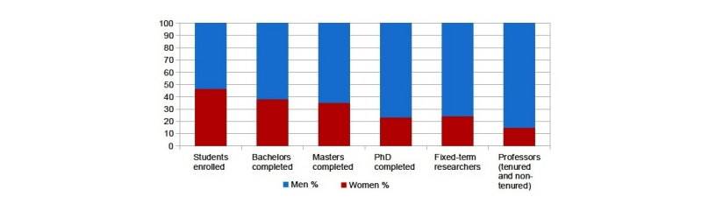

Infusino, Maria. “Gender distribution in Mathematics per study/career stage in 2014”. In: *Women in Mathematics in Germany.* [http://www.math.uni-konstanz.de/~infusino/KWIM/MInfusino-WIMGermany-report.pdf](http://www.math.uni-konstanz.de/~infusino/KWIM/MInfusino-WIMGermany-%09report.pdf). Last accessed: Jan 12, 2021.

## 6. Food for thought

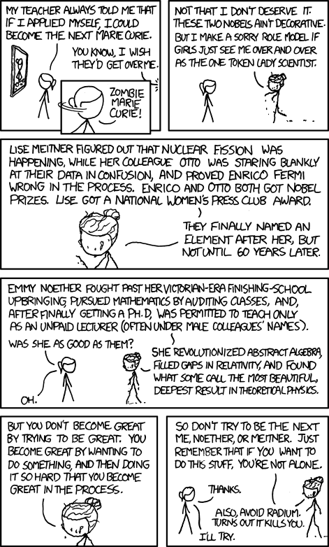

“Marie Curie.” *Xkcd*, xkcd.com/896/. Accessed: 02.12.2020

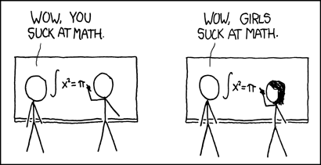

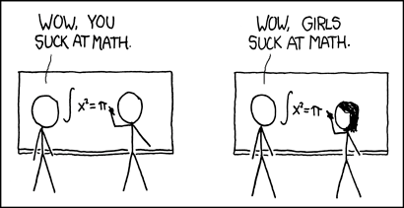

“How It Works.” Xkcd, xkcd.com/385/. Accessed: 02.12.2020

CC-BY-SA 4.0 <https://creativecommons.org/licenses/by-sa/4.0/>

Authors: Carla Cederbaum, Sophia Jahns, Anna Wienhard  
Contains materials and ideas developed by or in collaboration with: May-Britt Becker, Benjamin Cooke, Ingrid Daubechies, Katrin Grass, Mareike Kaina, Maria Rupprecht, Anna Schilling, Lea Schmid, Sarah Schott, and Michael Winckler.